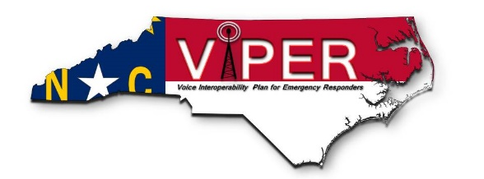
North Carolina Highway Patrol, VIPER Unit
3318 Garner Road
Raleigh, NC 27610
1-888-92-VIPER
919-662-4444 (fax)
https://www.ncdps.gov/our-organization/law-enforcement/viper

The State of North Carolina, VIPER System hereby grants authorization to
for operation of a Two-Way Radio Signal Booster device on 700/800 MHz frequencies licensed to the North Carolina State Highway Patrol by the Federal Communications Commission (FCC) under the call signs listed below at the following location: (Call Sign/Signs will be filled out by Radio System Owner)

Call Sign/Signs:
Location Name:
Location Address:
Latitude: |  | Longitude:
Location Contact: |  | Phone:
This authorization is subject to the following conditions:
- The System shall be operated, maintained, and tested annually in accordance with the manufacturer’s instructions, FCC rules and regulations, and requirements of the appropriate ordinances.
- The System shall not cause interference to radio systems or equipment operated by the North Carolina Highway Patrol, or any other FCC licensee.
- The Operator shall promptly resolve any interference that occurs to radio systems or equipment operated by the North Carolina State Highway Patrol, or any other FCC licensee, up to and including deactivation of the System if necessary, until such time that the interference is corrected.
- The Operator shall provide access to the System for inspection upon request by the North Carolina State Highway Patrol or the FCC.
- A separate Retransmission Authority is required for each headend used in the system design and shall be posted conspicuously with the Retransmission/Amplification equipment.
- The North Carolina State Highway Patrol, as FCC licensee for its frequencies, reserves the right to terminate this Authorization at any time at its sole discretion.
 |  |  | Date:
System Manager, North Carolina VIPER System

